# **Birthday Simulation Document**

## **Overview**

This program simulates the **Birthday Paradox**, showing how likely it is for at least two people in a group to share a birthday. It tests different group sizes and uses numerous trials to estimate this probability.

## **Key Components**

### **Person.java**

* Represents an individual with a randomly assigned birthday (a number between **1 and 365**).
* Contains methods to **set** and **retrieve** the birthday.

### **BirthdayFinder.java**

* Runs the birthday paradox simulation for a given **class size** and **number of trials**.
* Uses a **nested loop** approach to check for duplicate birthdays.
* Increments a counter whenever at least **one matching birthday** is found in a trial.

### **BirthdayTester.java**

* Takes **user input** for class size and number of trials.
* Runs the simulation using BirthdayFinder.
* Displays the probability of at least **two people sharing a birthday**.

## **Simulation Process**

1. A **group of people** (class size) is chosen.
2. Each person is assigned a **random birthday** (1-365).
3. The program **checks for duplicate birthdays** using a **nested loop**.
4. If a duplicate is found, that trial is **counted as a success**.
5. The simulation runs for the **specified number of trials**.
6. The probability of at least two people sharing a birthday is **calculated and displayed**.

## **Results**

* 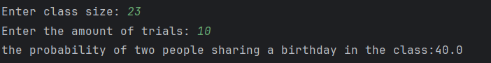
* 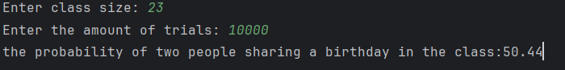
* As **class size increases**, the probability **rapidly approaches 100%**.

## **Conclusion**

This simulation shows that shared birthdays are more likely than expected, even in small groups. Running multiple trials gives a better estimate for the probability of two people sharing a birthday.